Econ 4410 International Trade

Professor: Steven Beckman

Shuo Liu, Yilin Wang, Kanika Manchanda

The Child Labor Problem

1.Introduction

Child labor is not a new phenomenon. According to the International Labor Organization, in 1995 there were at least 120 million of world’s children between the ages of five and fourteen years did full-time, paid work. (ILO 1996; Kebebew Ashagrie 1998) Many of them work under the terrible condition, sometimes they work longer than the adult.

Child labor exists in many countries at different historical stage. In the industrial revolution in Europe, the factories use a large number of child labor and female workers. For example, the share of cotton mill workers under eighteen in surveys in Manchester, Stockport, and Preston in 1816-9 were 47%, 58%, and 65% respectively, while by 1835 the corresponding figures had fallen to 39%, 36%, and 47 %.( Galbi, 1997) In Africa and Vietnam, the child labor is still a common situation.

Our purpose is to review the theory, give the reason why children work and specific examples and come up with some policies. Following the work of Basu and van's(1998), it is now widely recognized that child labor is a symptom of poverty and its eradication depends on economic development. This paper explores the development of this influential theory that puts the parents' decision to educate the child at the center of analysis. We then discuss the impact of fertility poverty and credit constraints on child labor. We end by discussing which policies appear to be most effective-education subsidies, minimum wages on other anti-poverty programs.

Fact

According to the ILO Convention No. 138 and No.146, The minimum age for work should not be below the age for finishing compulsory schooling, and in any case not less than 15. (Ilo.org, 2015) The definition of child labor of ILO is not very clear, because some children participate in activities which have the economic nature, such as the help the parents do some farm work.

Though the campaign against child labor made some achievement, child labor is still very serious. During 2008-2012, the number of child laborers decreased by 47 million, from 215 to 168 million. Until 2012, there are 85 million children do the hazardous work. Children in the 5-11 years age group account for by far the largest share of all child laborers: 73 million, or 44 per cent of the total child labor population. (ILO, 2013)

Table 1. Children in employment, child labor and hazardous work by age group, 2000-20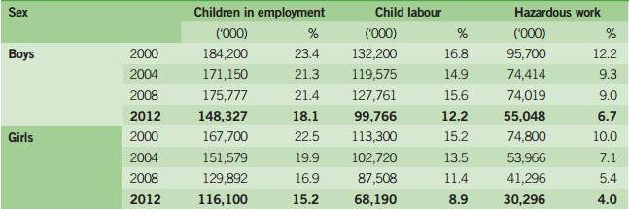12.

Whatever the developed countries or developing countries, there is no such a country has no child labour. Essentially, child labour almost exist every countries and it is a situation of degree.

2)Theory and Evidence

The menace of child labor has provoked intense debates over past two decades. In this section we examine the Basu theory model (1998) and some empirical evidence regarding families decision making and its connections for school and work choice for the child. We contemplate family’s decision making and market characteristics that restrict the options that households make regarding their children.

In specific , recent empirical and theoretical considerations has center on the role that failure of credit market play in child labor situation. Increasing access and more returns to education, changes in the social norms and development of financial market may all contribute towards the decline in child labor. An examination of link between child labor and poverty made it possible to differentiate between families’ characteristics and wider, macroeconomic phenomena.

Poverty

Poverty is one of the main reasons for increasing child labor in developing countries. Children are forced to work in order to support their families. Households have no choice but to send their children to work to support their livelihood. This can be defined as subsistence poverty.

Basu and Van (1998) discusses model that talks about the relationship between subsistence poverty and child labor. Their model is based on two crucial assumptions that are luxury axiom and substitution axiom. According to luxury axiom families put their children on work only when they are unable to meet the subsistence needs. Parents are considered to be altruistic and only send their children to work when compelled by circumstances. Substitution axiom states that child labor can be substituted in place of adult labor.

According to Levison and others (1998) there is link between substituting adult in place of child at work. They show that in India adults are almost as good as children in producing hand knotted carpets. So it is possible that child labor can be replaced by adult labor. But as adult labor costs more and for this reason carpet industries may resist and be reluctant to resort only on adult labor.

In the basic model, assuming that economy consists of N households and that each household consists of one adult and M represents number of children in the household .In the diagram below the wage is on the vertical axis and the quantity of labor on the horizontal axis. The two vertical lines are supplies of labor. One corresponds to adults working and the other to adults and children working. If the wage falls below the survival wage then both adult and children works. However if market wage is above the survival wage then only adult works.

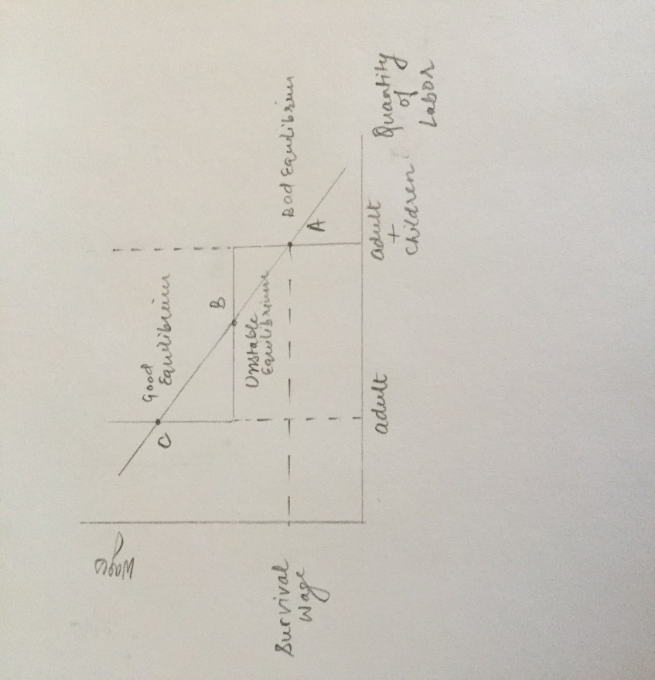

There are two stable equilibrium a low wage equilibrium where both adult and children works and a high wage equilibrium in which children are attending school. B represents unstable equilibrium.

There are two results that can be concluded from this model. Firstly the relation between the number of children per household and child labor. The basic needs of the family increases as m rises and thus adult wage should rise necessarily to ensure no child labor. If M raises sufficiently, the good equilibrium that is where only adult works disappear. Also if increase in m does not impact the good equilibrium, the child and adult equilibrium can be worse, by shifting it to point where both wages have fallen. Also increase in m can push economy to a point where bad equilibrium can come into existence, previously that not existed. These can be some of the reasons that how increased fertility can be associated with increased child labor.

Secondly that both bad and good equilibrium co exists, while economy is on bad equilibrium. Basu and Van (1998) discusses how the ban on child labor can impact the equilibrium wage. If child labor is banned then employers have to fill the vacant position with adult workers and as a result adult wage rises to good equilibrium level. At this point families will send their kids to school and stop supplying child labor. If the good equilibrium is not there then the families will be worse with child labor ban. Ban will give rise to new equilibrium where the adult wage is higher, but the wage will be under the critical level, necessary to meet basic livelihood needs. Therefore prohibition of child labor may only work if good equilibrium exists.

Parental influence

The assumption in theoretical models of child labor is that parents make decisions according to allocation of household resources. So parental preferences play an important role in making the decisions that if children go to work or go to school.

“Rogers and Swinnerton (2004) modify the model un Baland and Robinson (2000) and show that when both parents and children are altruism, the relationship between parental income and child labor may exhibit an invert-U shape”. Since parents may dependent on transfer from their adult children in low income families. In another words, those adults’ children who works and get salary are supporting their family. However, the level of parents’ income is the indirect influence of decision if children go to work. As a result, parents in low income family may increase the hours that their children go to work and decrease the hour children go to school. Only when parental income is high enough to maintain households well, then the child labor may decline with parental income.

Related to the discussion on altruism is whether or not there is a positive stigma towards child labor. Even most of literature assumes that parents will only send their children to work if poverty or there binding constraints compel them to, Patrinos and Shafiq (2010) discuss the case where parents may have a positive attitude towards child labor. Some parents think that child labor is safe, and also has benefits of teaching children valuable skills. Those kinds of parents keep the opinions that child labor can learn responsibility, social morality, and discipline which can be combined with school. So parents would like children to work since those parents regard child labor as important as school education.

A third parental reason which influences child labor would be the level of parents’ education. There is increasing evidence that parents with higher education are more likely to send their children to school and keep them out of labor force (e.g. Strauss and Thomas (1995)). As a result, well-educated parents would have a greater preference for education since high education level parent’s gains high returns from “intergenerational transmission of human capital”. Emerson and Souza (2007) find that it is the father’s education that has the greatest impact on children’s education level using the data from Brazil. Therefore, the research on parental characteristics leads to the agency aspect of child labor. As parents often make decisions on behalf of their children, influencing parental characteristics play a significant role in reducing child labor.

Credit Market Imperfection

Subsistence poverty alone is not the reason for child labor. If families are credit constrained then children are forced to work. If family income will be rising over time, then the parent may find it favorable to borrow against the future so as to have stable consumption over the course of time. That is savings will be negative when kids are young. Nevertheless, if parents do not have easy and cheap access to credit markets then they have to depend on internal assets. In child labor case, parents put their children at work rather than investing in human capital that will make their kids more efficient and productive in future. However this strategy is favorable for the family in the credit constrained situation but is not effective.

Ranjan (1999) discuss a two- period model where family has to decide between whether to send the child to work or to school in first period. There are two kinds of wages, adult wage and child wage. Adult wages can further be categorized in two types – skilled wage and unskilled wage. Also child wage is less than unskilled wage. And there is no livelihood constraint. If child works in first period he will earn child wage in first period and in second period he will unskilled wage. A child who attends school in first period and works in second period will earn no wage in first period and skilled adult wage in second period.

There are two cases, first where families have entry to the international capital market and can borrow money at interest rate *r.* And in the second case, where households doesn’t have access to credit markets. Ranjan’s model shows that in case 1 family will always to choose to send their children to school rather putting them on work if return on education, *i,* is more than market interest rate i.e. *i > r* , despite of the initial level of family income. In second case, Ranjan reveals that there is minimum level of family income above which all households will send their children to school, however, if income is below this level then households have no choice and are forced to put their children on work. The reason is that, at low levels of income the marginal utility linked with sacrificing child wage is quite high, and more than compensates the future value in benefits from the greater skilled wage.

Dehejia and Gatti (2002) discover an inverse relationship between child labor and role of credit constrained. They evaluate a basic model of child labor determining for a panel of 172 countries for the years 1950-60, 70, 80 and 95. The credit constraint variable is proxied by the GDP share of credit institution. They discover that an increase of one standard deviation in GDP share of credit is linked with 10% decrease in child labor standard deviation. Concluding that families are less likely to send their children to work if they have access to credit during economic volatile period than families facing credit constraints.

Social norms customs and discrimination.

Some economists argue that decision if sending a child to go out to work depend on social customs (Helena s. and Dukey, 2002). If other families let their children to be educated, but there is only one family let child to be child labor, then the child labor family's parents will face big moral condemnation. This family will be judged egoism by social norms. So the parents are very difficult to make such a decision only let his children to word among other educated children. On the contrary, if child labor is widespread, so a family which let children work would face much smaller social pressure. As a result, in some poor countries, the high number of child labor would be. a normal phenomenon.

Lack of quality school

Dessy & Pallage (2001) in a related study in Pakistan found that due to a lack of good schools, and parents to their children by education of the future earnings discount is low which lead to the emergence of a large number of child labor. Jensen, and Nielsen (1997) over the study also found that, since there is no (or without proper) schools, a large number of families failed to send children to school, part of the children drop out from schools and become a child labor. In fact, the more poor families tend to live in the more backward countryside developing country, sparsely populated region, there is impossible to have the appropriate school (or far away from the school). High cost of natural conditions make those children give up going to school. In addition, if the number of school teachers is not enough then the quality of education will be decreased. Also parents will push their children into the labor market since they have lower returns of education than their exception.

3)Policy Child labor problem has already attracted human’s attention. Each country establishes different laws in order to decrease even eliminate child labor. Governments have tried different types to interpose child labor. Some area’s government try to do coercive interposes which means that each country’s governments or international organizations issue compulsory policy. However, there are still some disadvantages of coercive policy.

Firstly, there is disparity between Implements and laws. In terms of law, there are three different forms of intervention : intervention within a country (intra - national) law, which is enacted by a state government, the main purpose is to control its internal number of child labor; Super borders (supra - national) in the form of legal intervention, this is with the aid of some international organizations, such as the ILO, WTO and UNICEF, the purpose is to require all signatories to take measures to control number of child labor; And for extra - national legal intervention in other countries, such as some developed countries refused to imports from Child Labor abuse country or enterprise, such as the United States of the interference using Child Labor Act (US Child Labor Deterrence Act, 1993), although promulgated by the United States, but mainly for the third countries (Basu, 1999). Even the government establish the policy to force factories do not employ child labor, there do exist consciousness of low-income country’s citizen. Some of the parents in low-income country allow their child to be a child labor since they does not realize the relationship between child labor to lack of education. They did not realize the importance that lack of education would result in their family’s poorness. Exactly, in some low-income country, to earn their life to make their family alive is much significant than go to school. Besides, some city does need cheap labor power. For example, developing country which is famous for textile industry, handicraft industry or processing process, those factories are as cheap cost for competitive advantage. In order to abstract more order of goods, they have to decrease the cost of skilled labor. Instead of skilled labor, factory would prefer to employ child labor which is unskilled but lower cost. Even the government obtains laws to prohibit child labor, in front of benefit, those factories choose to ignore the laws and insist employing child labor. The result is that a large number of children are forced to work in the informal sector. And the informal sector work unsupervised and dangerous , tend to form more bad, more dangerous work, also more bad for children's growth. Although there are many forms of law, the scholars realized that in different areas, different policy should be implemented, in particular in poor areas if not from place to place and if appropriate, will often backfire. Now, outright bans on child labor is not only impossible (may let the child from the formal sector to more difficult to supervise the informal sector), and may lead to some countries, small to a specific family, even the welfare of the child himself deterioration. Because usually, the causes of child labor is often the extreme poverty, caused by cancellation of child labor and the effect of the rise of adult wages and household income to reduce the effect of which is greater still difficult to determine, in some cases, child labor work income is essential not only for some families, and is the child Labour itself, is he to maintain the necessary level of health and nutrition, accept education indispensable conditions (Ray, 2000; Dessy and Pallage, 2001).

Therefore, the policy does not guarantee that all child labor would go to school. Even children give up to be child labor in factory, not all of them choose to back to school to be educated. In poor country, child may help their poor family to earn life. They may do housework or take care of brothers and sisters, or even be engaged in agriculture to help family. Also there do exist some underground illegal factory. Not only they can escape from government’s tax, but also they use child labor to be their illegal workers. Those kind of underground illegal factory usually protect them really well. The government, the police, even the citizen are difficult to publish them.

The minimum wage law is a kind of effective approach? As for child labor in the formal sector work, it does have certain effect, but for the informal sector, especially in the vast majority of the distribution of child labor in the countryside, it has little effect. The results of the empirical study are not fully support this way. For example, from a historical point of view, in terms of the United States, in the last century, the minimum wage law only impact on employment and child Labour only weak (Moehling, 1999).

Except the minimum wage law, another can be very effective legal form is the compulsory is the education law. Many countries have their own legal minimum of compulsory education and legal working age, the world average of about 15 years old through the compulsory education law, mandatory provisions. Within the scope of a certain age children must accept education in school, so as to achieve the goal of indirectly reduce child labor. However, if a country eager to implement compulsory education, then it must be on the obligations stipulated in the education subsidies. Otherwise the situation will appears on the one hand that countries would school-age children have to accept compulsory education, and on the other hand, poor families cannot afford the costs of education embarrassing situation through compulsory education also is difficult to achieve the purpose of reduce child labor.

5)Conclusion

The aim of this paper has been to explain the fact that there is no particular underlying factor accountable for the phenomenon child labor. Somewhat subsistence poverty, credit market failure or imperfections and parents’ choice to send their children to school or at work, all may contributes toward child labor. As a consequence, no specific policy instrument policy instrument can be presumed to eliminate child labor.

Putting bans on child labor or boycotting the products produced by child labor is not the solution to eradicate child labor. As these policies does not solve the purpose to eliminate the root cause of child labor. Rather these kinds of policies can sometime have negative effects, making children and households worse off. These boycotts and bans do not produce the desired results if households don’t have alternative options.

For successfully eradicating child labor, policymakers must come up with more sophisticated policies that address to the root cause and provide alternative opportunities. Policies like introducing minimum wage law and compulsory education and developments of financial markets can help government to tackle with the problem of child labor.

References

1. Galbi, D. (1997). Child labor and the division of labor in the early English cotton mills. Journal Of Population Economics, 10(4), 357-375. <http://dx.doi.org/10.1007/s001480050048>

2. ILO (1996), Economically Active Populations: Estimates and Projections, 1950-2010, International Labor Organization, Geneva.

3. Ilo.org,. (2015). ILO Conventions and Recommendations on child labour (IPEC). Retrieved 29 November 2015, from [http://www.ilo.org/ipec/facts/ILOconventionsonchildlabour/lang--en/index.htm](http://www.ilo.org/ipec/facts/iloconventionsonchildlabour/lang--en/index.htm)

4.ILO-IPEC(2013), Marking progress against child labour - Global estimates and trends 2000-2012 / International Labour Offie, International Programme on the  
Elimination of Child Labour (IPEC) - Geneva: ILO, 2013.

5. Basu, K. and Van, P. (1998) The economics of child labor. American Economic Review 88(3): 412–427

6. Levison , D., R. Anker, S. Ashraf, and S. Barge. 1998. “ Is child labor really necessary in India’s carpet industry ?” In R. Anker,S. Barge , S. Rajagoaple and M.P. Joseph, eds., Economics of child labor on hazardous industries of India . New Delhi :

Hindustan Publishers

7. Ranjan, P. (1999) An economic analysis of child labor. Economics Letters 64: 99–105

8. Dehejia, R. and Gatti, R. (2002) Child labor: the role of income variability and access to credit across countries. NBER Working Paper 9018, Cambridge

9. Baland,J. and Robinson,J (2000) Is child labor inefficient? Journal of Political Economy 108(4):663-679

10. Emerson,P. and Souza, A(2007) child labor, school attendence, and intrahoused gender bias in Brazil. The world bank economic review21(2):301-316

11. Patrinos,H and Shafiq,N.(2010) An empirical illustration of positive stigma towards child labor. Economics Bulletin30(1):799-807

12. Rogers C and Swinnerton,K.(2004) Does child labor decrease when parental income rise? Journal of Political Economy 112:939-946.

13. Strass,J. and Thomas,D. (1995) Human resouces: empirical modeling of household and family decisions. In J. Behrman and T.Srinivasan(eds),Handbook of Development Economics (Volume 3, pp. 1883-2023). Amsterdam,Netherlands:North-Holland.

14. Grootaert, Christiaan, 1998, “Child Labor in Cote d’Ivoire: Incidence and Determinants”, in Grootaert, Christiaan and Patrinos, Harry, eds., The Policy Analysis of Child Labor: A Comparative Study, manuscript, World Bank, Washington.

15. Nielsen, Helena S. and Dukey, Amaresh., 2002, “Child Labour in Rural India: A Micro-economic Perspective”, The Indian Journal of Labour Economics , Vol .45（3）, pp. 479-496

16. Dessy, Sylvain. and Pallage,, St´ephane., 2001, “Child Labor and Coordination Failures”, Journal of Development Economics, vol. 65(2), pp. 469 – 476.

17. Dessy, Sylvain. and Pallage,, St´ephane., 2001, “Why Banning the Worst Forms of Child Labour Would Hurt Poor Countries”, Cahier de echerche CREFE / CREFE Working Paper No. 135.

18. Dessy, Sylvain. and Knowles, John, 2001, “Why is Child Labor Illegal?”, PIER Working Paper No. 01-043

19. Jensen , P. and Nielsen , H.S., 1997, “Child Labor or School Attendance? - Evidence from Zambia'”, Journal of Population Economics, vol..10（4）, pp. 407-424

20. Basu, Kaushik, and Van, Pham Hoang, 1999, “The Economics of Child Labor：reply”, American Economic Review, vol. 89（5）, pp. 1386 -1388.

21. Basu, Kaushik 1999, “child labour: Cause, Consequence and Cure, with Remarks on International Labor Standards”, Journal Economic Literature, vo. l37（3）, pp. 1083-1119

22. Ray, Ranjan , 2000, “Analysis of Child Labor in Peru and Pakistan: A Comparative Study”, Journal of Population Economics, vol.13（1）, pp. 3-19.

23. Ray, Ranjan, 2000, “Child Labor, Child Schooling, and Their Interaction with Adult Labor: Empirical Evidence for Peru and Pakistan”, The World Bank Economic Review, Vol. 14（2）, pp. 347–367.

24. Dessy, Sylvain. and Pallage,, St´ephane., 2001, “Child Labor and Coordination Failures”, Journal of Development Economics, vol. 65(2), pp. 469 – 476.

25. Dessy, Sylvain. and Pallage,, St´ephane., 2001, “Why Banning the Worst Forms of Child Labour Would Hurt Poor Countries”, Cahier de echerche CREFE / CREFE Working Paper No. 135.

26. Moehling, Carolyn M., 1999, “State Child Labor Laws and the Decline of Child Labor”, [Explorations in Economic History,](http://www.sciencedirect.com/science?_ob=journalurl&_cdi=6796&_auth=y&_acct=c000050221&_version=1&_urlversion=0&_userid=10&md5=e6824cdc9c2866baf05bb7423a4e964c) [Volume 36（1](http://www.sciencedirect.com/science?_ob=issueurl&_tockey=%25252523toc%252525236796%252525231999%25252523999639998%25252523302957%25252523flp%25252523display%25252523volume_36,_issue_1,_pages_1-107_(january_1999)%25252523tagged%25252523volume%25252523first%2525253d36%25252523issue%25252523first%2525253d1%25252523pages%25252523first%2525253d1%25252523last%2525253d107%25252523date%25252523(january_1999)%25252523&_auth=y&view=c&_acct=c000050221&_version=1&_urlversion=0&_userid=10&md5=3de28873aea4a92d7d8f64a754fcbaee)）, pp. 72-106